**Exercise 1: Configuring a Basic Spring Application**

**Steps:**

1. **Set Up a Spring Project:**
   * Create a Maven project named **LibraryManagement**.

Project Structure:

* + 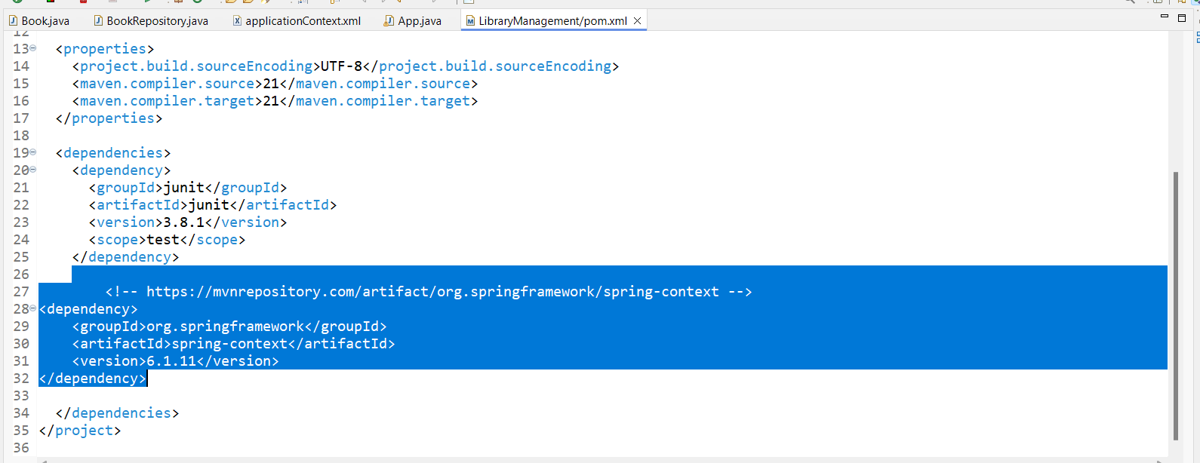Add Spring Core dependencies in the **pom.xml** file.

1. **Configure the Application Context:**
   * 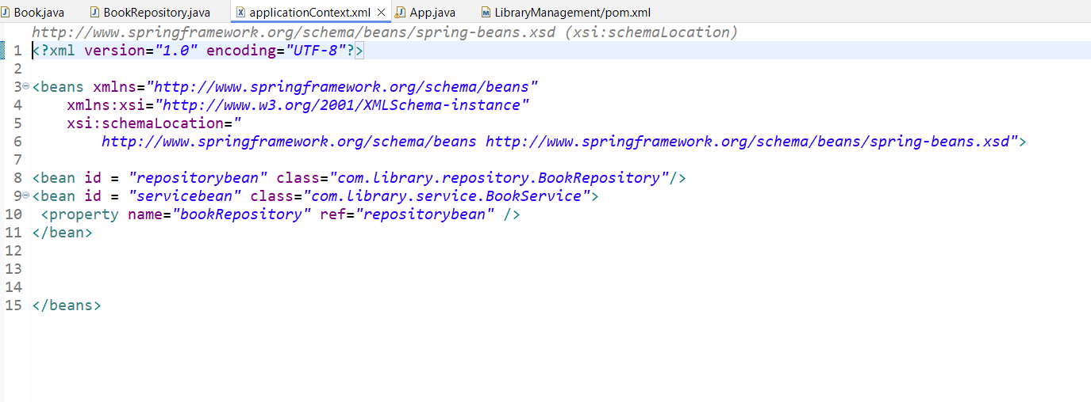Define beans for **BookService** and **BookRepository** in the XML file.
2. **Define Service and Repository Classes:**
   * A computer screen shot of a program

     Description automatically generatedCreate a package **com.library.service** and add a class **BookService**.
   * Create a package **com.library.repository** and add a class **BookRepository**.

1. **Run the Application:**
   * Create a main class to load the Spring context and test the configuration.

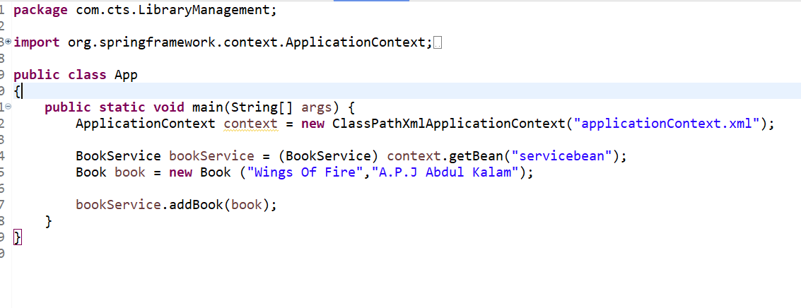

Output:

